SIMATS ENGINEERING
Department of Computer Science & Engineering
ASSESSMENT TOOL 1- EXPERIMENTS

Course Code: | CSA12 02 | Course Title: | Computer Architecture
CO Assessed: | CO3 | Assessment: | ASSESSMENT TOOL 1- EXPERIMENTS
Weightage: | 40% | Total Marks: | 25
CO3 Statement: | Design processor organization by constructing pipelined datapath structures, identifying hazard types (data, control, structural), and comparing superscalar techniques such as out-of-order execution, speculative execution, and simultaneous multithreading (SMT). (BL6)
Student Name: | P Dinesh Reddy | Reg.No.: | 192525399
Department: |  | Date:

Code of Conduct:

I P Dinesh Reddy / 192525399 (Name / Reg No) certify that this submission is my original work and that I have adhered to the guidelines specified for this assessment.I understand that any violation of academic integrity rules will result in disciplinary action.

Signature of the student:

ANNEXURE A

- Design and simulate a system that performs register transfer operations along with basic arithmetic and logic operations such as addition, subtraction, AND, and OR. Use multiple registers to demonstrate how data is transferred between them during execution, and analyze the sequence of operations and the role of the ALU in processing data.
design and simulate a register transfer and ALU system performing basic arithmetic and logic operations.
Components: Registers (R1, R2, R3, R4), ALU, common bus, and control unit.
Example: Let R1 = 15 (00001111) and R2 = 10 (00001010).
Operation | Register Transfer / ALU Operation | Result
Transfer | R3 ← R1 | 15
Addition | R3 ← R1 + R2 | 25
Subtraction | R3 ← R1 − R2 | 5
AND | R3 ← R1 AND R2 | 10
OR | R3 ← R1 OR R2 | 15

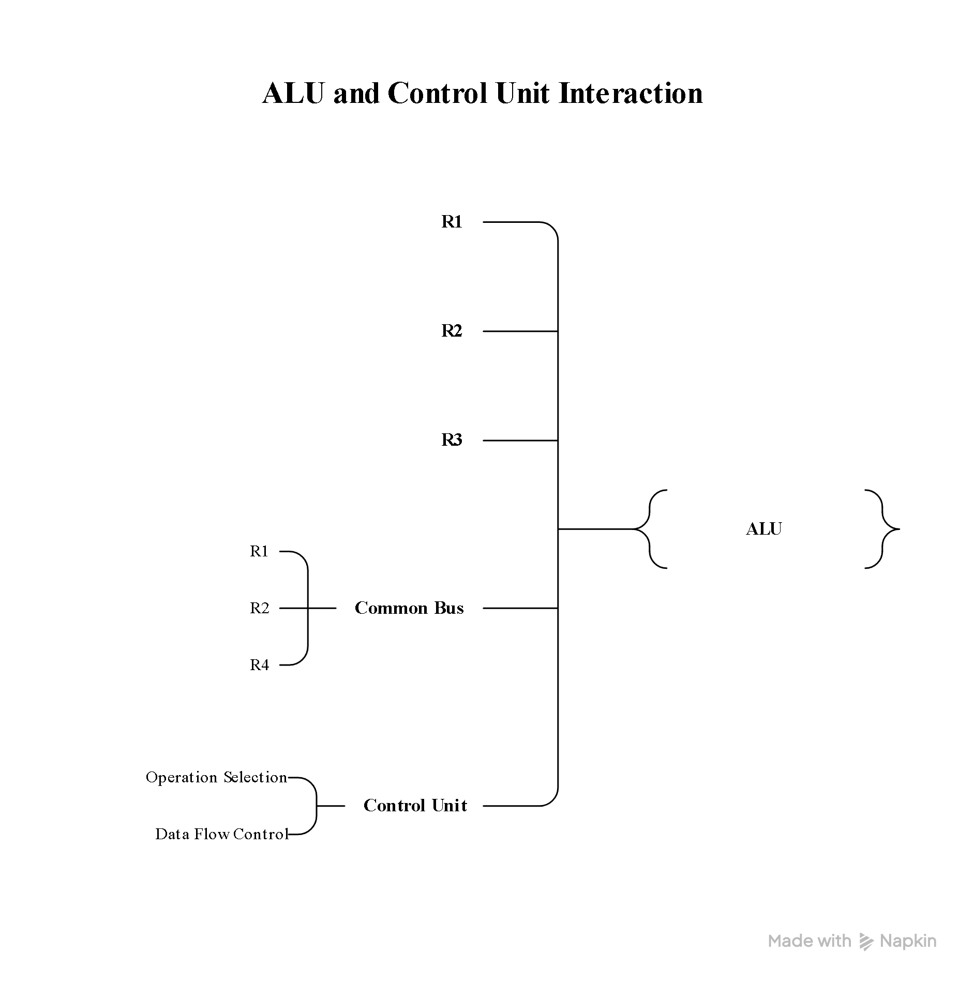
Sequence: Data is transferred from source registers to the ALU through the bus; the ALU performs the selected operation, and the result is stored in the destination register.

Role of ALU: The ALU performs arithmetic and logical operations based on control signals.
Result: The system successfully demonstrates register transfer, arithmetic, and logical operations using multiple registers and an ALU.

- Create a model of a computer system using single-bus and multi-bus organization, and perform data transfer operations between registers, memory, and I/O. Compare the time taken and efficiency of both approaches, and analyze how multiple bus structures improve parallel data transfer and reduce bottlenecks.

Single-Bus and Multi-Bus Organization

Model and compare single-bus and multi-bus computer organizations for data transfer between registers, memory, and I/O.

Block Diagram

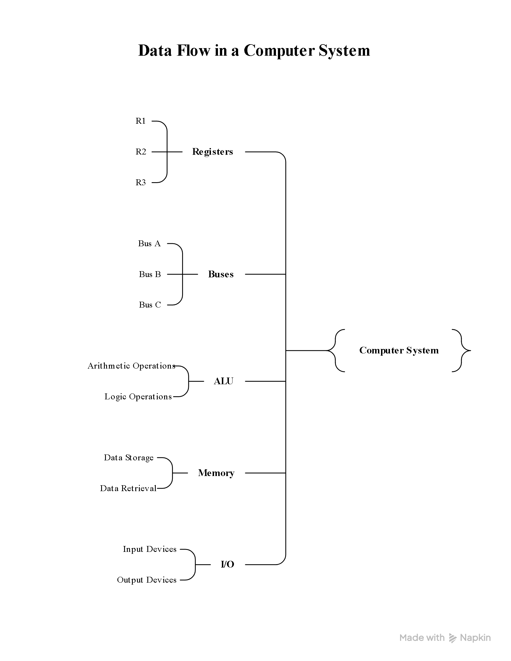
Single-Bus Organization Multi-Bus Organization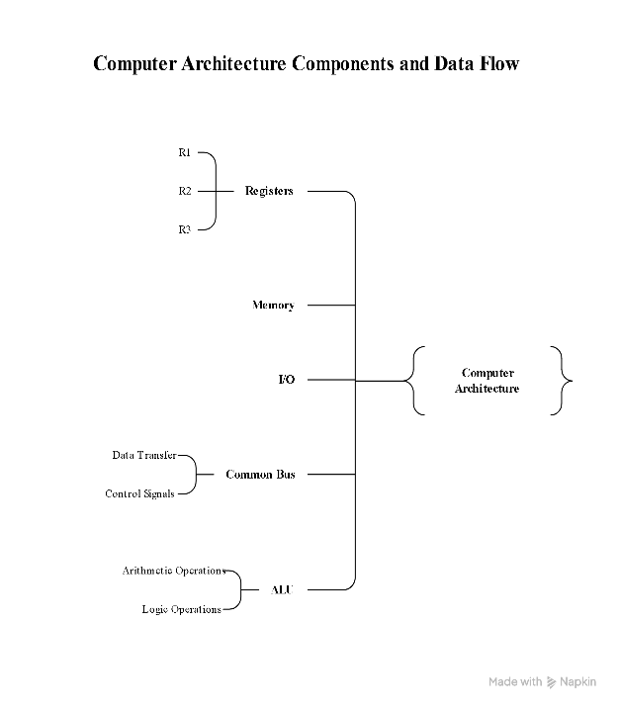

Data Transfer

Organization | Example Transfer | Time/Efficiency
Single Bus | Memory → Bus → R1 → Bus → R2 | More cycles; lower efficiency
Multi Bus | Memory → Bus A → R1 and R2 → Bus B  simultaneously | Fewer cycles; higher efficiency
Comparison
- Single-bus: One common path is shared by all components, so only one transfer occurs at a time, creating a bottleneck.
- Multi-bus: Multiple independent paths allow simultaneous transfers, reducing waiting time.
- Efficiency: Multi-bus organization provides faster data movement and better CPU utilization.
Conclusion:
Multi-bus systems are faster and more efficient because parallel data transfers reduce bus contention and execution time.

- Simulate a 5-stage instruction pipeline (Fetch, Decode, Execute, Memory, Write-back) and execute a set of instructions. Measure the performance in terms of speedup and throughput, and compare it with a non-pipelined system to evaluate the effectiveness of pipelining.
Aim: To simulate a 5-stage pipeline and compare its performance with a non-pipelined processor.
Pipeline Stages
IF → ID → EX → MEM → WB
IF: Instruction Fetch
ID: Instruction Decode
EX: Execute
MEM: Memory Access
WB: Write Back
Pipeline Diagram
┌─────┐ ┌─────┐ ┌─────┐ ┌─────┐ ┌─────┐
Instruction│ IF │→│ ID │→│ EX │→│ MEM │ → │ WB │
└─────┘ └─────┘ └─────┘ └─────┘ └─────┘
Fetch Decode Execute Memory Result
Example: 4 Instructions
Cycle → 1 2 3 4 5 6 7 8
I1 IF ID EX MEM WB
I2 IF ID EX MEM WB
I3 IF ID EX MEM WB
I4 IF ID EX MEM WB
Performance Comparison
For n = 4 instructions and 5 stages:
Non-pipelined cycles:
Pipelined cycles:
Speedup:
Throughput:
After the pipeline is filled, one instruction completes every clock cycle.
Result
The pipelined processor completes 4 instructions in 8 cycles instead of 20 cycles, achieving a 2.5× speedup. Pipelining improves throughput by allowing multiple instructions to be processed simultaneously in different stages.

- Develop a pipeline execution scenario where data hazards, control hazards, and structural hazards occur. Observe their impact on instruction execution, and implement techniques such as stalling, data forwarding, and branch prediction to resolve these hazards and improve performance.

Pipeline Hazards and Their Resolution
Aim: To simulate data, control, and structural hazards in a 5-stage pipeline and apply techniques to improve performance.
Pipeline Stages
IF → ID → EX → MEM → WB
Hazard Examples
Hazard | Example | Problem | Solution
Data | ADD R1,R2,R3 → SUB R4,R1,R5 | SUB needs R1 before it is written | Data forwarding / Stall
Control | BEQ R1,R2,L1 | Next instruction is uncertain | Branch prediction
Structural | Instruction fetch and data access use same memory | Resource conflict | Stall / Separate memories
Pipeline Scenario
Cycle → 1 2 3 4 5 6 7
I1 ADD IF ID EX MEM WB
I2 SUB IF ID EX MEM WB
I3 BEQ IF ID EX
I4 LOAD IF ID EX MEM WB
Hazard Resolution
Data forwarding: Directly sends the result from one pipeline stage to another without waiting for register write-back.
Stalling: Inserts a bubble when the required data/resource is unavailable.
Branch prediction: Predicts the branch direction so instruction fetching can continue without waiting.
Impact
Without hazard handling, pipeline stalls and incorrect instruction execution reduce performance. Forwarding minimizes data stalls, branch prediction reduces control delays, and separate resources reduce structural conflicts.
Result: Hazard-resolution techniques improve pipeline efficiency, reduce stalls, and increase instruction throughput.

- Analyze a processor supporting superscalar execution, including out-of-order and speculative execution, and extend the study to include hyper-threading and simultaneous multithreading (SMT). Evaluate how multiple instructions are executed in parallel and compare the performance improvements in terms of instruction throughput and resource utilization.

Blo Superscalar, Out-of-Order and SMT Execution
Aim: To analyze parallel instruction execution using superscalar, out-of-order, speculative execution, and SMT techniques.
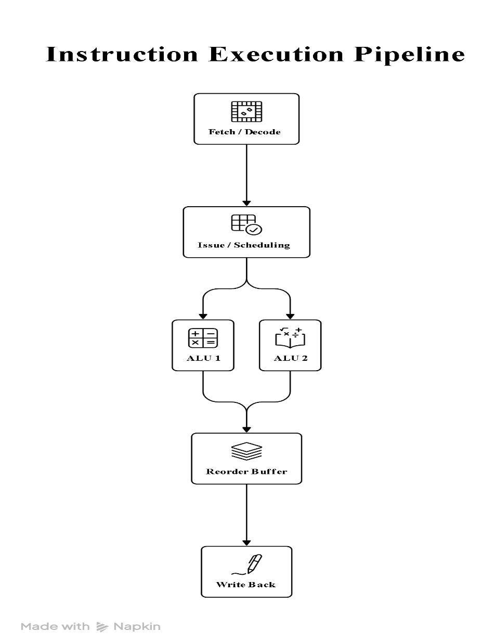
Block Diagram

Execution Scenario
For a 4-wide superscalar processor, up to 4 independent instructions can be issued in one cycle.
Cycle 1 → I1 I2 I3 I4
Cycle 2 → I5 I6 I7 I8

Out-of-order execution: Executes ready instructions before stalled instructions.
Speculative execution: Executes predicted instructions before the branch outcome is confirmed.
Hyper-threading / SMT: Allows multiple hardware threads to share processor resources and execute instructions concurrently.
Performance Comparison
Technique | Main Benefit | Throughput
Single issue | One instruction/cycle | 1 IPC
4-wide superscalar | Multiple instructions/cycle | Up to 4 IPC
Out-of-order | Uses idle execution units | Higher utilization
Speculative execution | Reduces branch delays | Higher throughput
SMT/Hyper-threading | Uses resources from multiple threads | Better resource utilization
Result
Superscalar execution increases instruction-level parallelism, while out-of-order and speculative execution reduce waiting time. SMT/Hyper-threading keeps processor resources busy by executing instructions from multiple threads. Overall, these techniques improve instruction throughput and resource utilization, although actual performance depends on instruction dependencies and available processor resources.

RUBRICS FOR CALCULATION:

Criteria | Weightage | Level 4 – Exemplary | Level 3 –  Proficient | Level 2 –  Developing | Level 1 –  Beginning
Understanding of Concepts | 25 | Demonstrates thorough understanding and  effectively integrates multiple concepts/technologies | Good understanding with proper  integration of most concepts | Basic understanding;  limited or partial integration | Poor understanding; unable to  integrate concepts
Experimental Design | 30 | Well-planned, systematic implementation with optimal solution | Correct implementation with minor issues | Basic implementation with errors or inefficiencies | Incorrect or incomplete implementation
Use of Tools | 20 | Effective and advanced use of tools/technologies with proper configuration | Appropriate use of tools with correct execution | Limited or inconsistent use of tools | Incorrect or minimal use of tools
Analysis of Results | 15 | Insightful analysis with accurate interpretation and validation of results | Good analysis with reasonable interpretation | Basic analysis with limited insights | Poor or incorrect analysis of results
Documentation | 10 | Clear, well-structured documentation with  diagrams, code, and results | Organized documentation with necessary details | Basic documentation  with missing details | Poor or incomplete documentation

